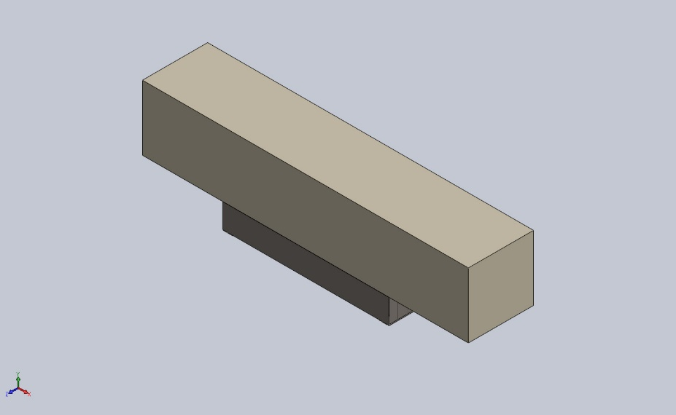
  Simulation of JLLMain Dock Leveler Assembly
  Date: 08 October 2025
  Designer: Bharati Sabale
  Study name: Static 2
  Analysis type: Static
  Table of Contents
  Description 1
  Assumptions 2
  Model Information 3
  Study Properties 11
  Units 11
  Material Properties 12
  Loads and Fixtures 14
  Connector Definitions 14
  Interaction Information 15
  Mesh information 16
  Sensor Details 17
  Resultant Forces 17
  Beams 18
  Study Results 22
  Conclusion 24

Description
No Data

Assumptions

Model Information

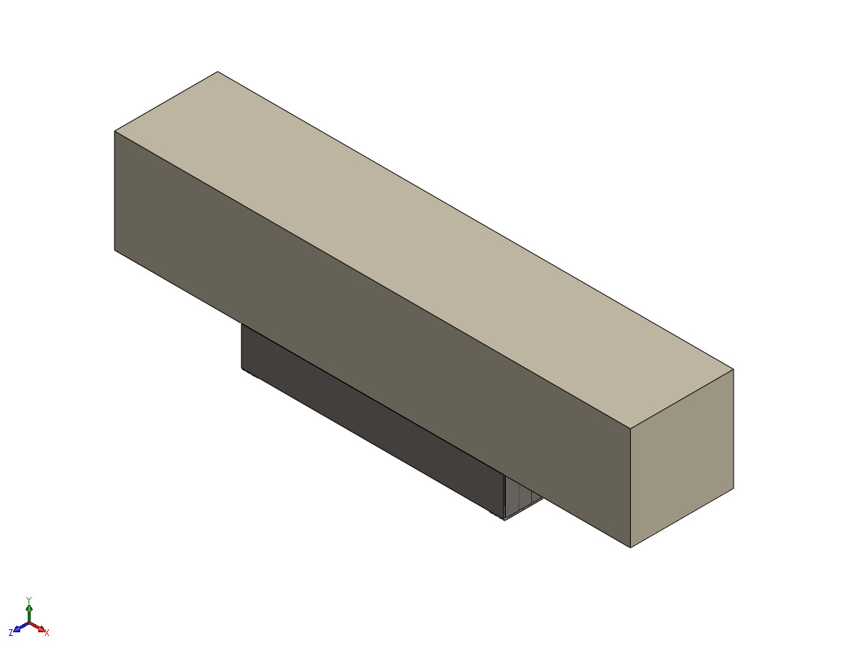
Model name: JLLMain Dock Leveler Assembly
Current Configuration: Default
Solid Bodies
Document Name and Reference | Treated As | Volumetric Properties | Document Path/Date Modified
Boss-Extrude1 | Solid Body | Mass:6.28 kg  Volume:0.0008 m^3  Density:7,850 kg/m^3  Weight:61.544 N | E:\NIHVA AUTOMATION 2026\AUTOMATION\DOCK LEVELER\JLL\JLLPLATE BOTTOM.SLDPRT  Oct 8 05:58:42 2025
Boss-Extrude1 | Solid Body | Mass:3.768 kg  Volume:0.00048 m^3  Density:7,850 kg/m^3  Weight:36.9264 N | E:\NIHVA AUTOMATION 2026\AUTOMATION\DOCK LEVELER\JLL\JLLPLATE.SLDPRT  Oct 8 05:33:55 2025
Boss-Extrude1 | Solid Body | Mass:6.28 kg  Volume:0.0008 m^3  Density:7,850 kg/m^3  Weight:61.544 N | E:\NIHVA AUTOMATION 2026\AUTOMATION\DOCK LEVELER\JLL\JLLPLATE BOTTOM.SLDPRT  Oct 8 05:58:42 2025
Boss-Extrude1 | Solid Body | Mass:3.768 kg  Volume:0.00048 m^3  Density:7,850 kg/m^3  Weight:36.9264 N | E:\NIHVA AUTOMATION 2026\AUTOMATION\DOCK LEVELER\JLL\JLLPLATE.SLDPRT  Oct 8 05:33:55 2025
Boss-Extrude1  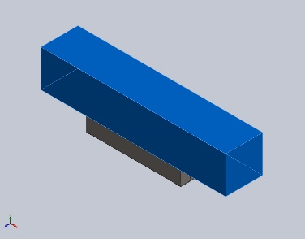 | Solid Body | Mass:39,250 kg  Volume:5 m^3  Density:7,850 kg/m^3  Weight:384,650 N | E:\NIHVA AUTOMATION 2026\AUTOMATION\DOCK LEVELER\JLL\JLLBS.SLDPRT  Oct 6 21:38:44 2025
Boss-Extrude1  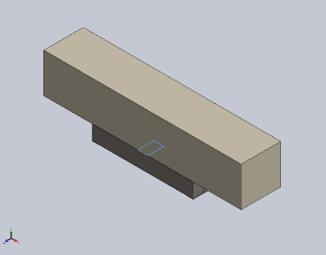 | Solid Body | Mass:6.28 kg  Volume:0.0008 m^3  Density:7,850 kg/m^3  Weight:61.544 N | E:\NIHVA AUTOMATION 2026\AUTOMATION\DOCK LEVELER\JLL\JLLPLATE BOTTOM.SLDPRT  Oct 8 05:58:42 2025
Boss-Extrude1  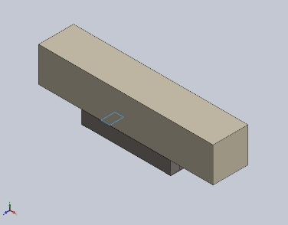 | Solid Body | Mass:6.28 kg  Volume:0.0008 m^3  Density:7,850 kg/m^3  Weight:61.544 N | E:\NIHVA AUTOMATION 2026\AUTOMATION\DOCK LEVELER\JLL\JLLPLATE BOTTOM.SLDPRT  Oct 8 05:58:42 2025
Boss-Extrude1  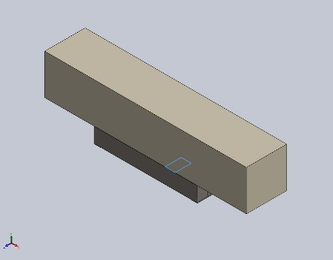 | Solid Body | Mass:6.28 kg  Volume:0.0008 m^3  Density:7,850 kg/m^3  Weight:61.544 N | E:\NIHVA AUTOMATION 2026\AUTOMATION\DOCK LEVELER\JLL\JLLPLATE BOTTOM.SLDPRT  Oct 8 05:58:42 2025
Beam Bodies:
Document Name and Reference | Formulation | Properties | Document Path/Date Modified
SolidBody 1(C channel 100 X 10(1)[1])  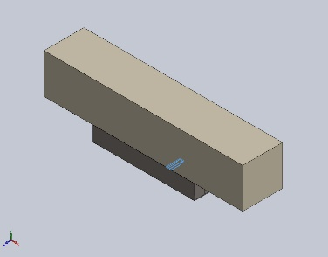 | Beam – Uniform C/S | Section Standard-weldment profiles/iso/c channel  Section Area: 0.00131018m^2  Length:330.289mm  Volume:0.000413477m^3  Mass Density:7,850kg/m^3  Mass:3.2458kg  Weight:31.8088N | E:\NIHVA AUTOMATION 2026\AUTOMATION\DOCK LEVELER\JLL\C CHANEL.SLDPRT  Oct 8 05:26:37 2025
SolidBody 2(C channel 100 X 10(1)[2])  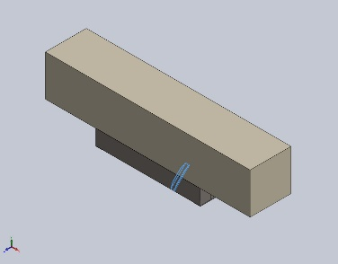 | Beam – Uniform C/S | Section Standard-weldment profiles/iso/c channel  Section Area: 0.00131018m^2  Length:397.627mm  Volume:0.000584747m^3  Mass Density:7,850kg/m^3  Mass:4.59026kg  Weight:44.9846N | E:\NIHVA AUTOMATION 2026\AUTOMATION\DOCK LEVELER\JLL\C CHANEL.SLDPRT  Oct 8 05:26:37 2025
SolidBody 3(C channel 100 X 10(1)[3])  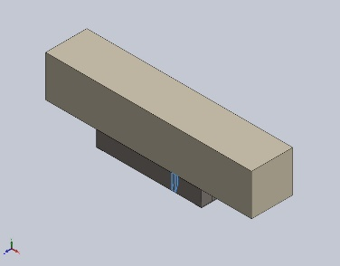 | Beam – Uniform C/S | Section Standard-weldment profiles/iso/c channel  Section Area: 0.00131018m^2  Length:291.243mm  Volume:0.000413463m^3  Mass Density:7,850kg/m^3  Mass:3.24569kg  Weight:31.8077N | E:\NIHVA AUTOMATION 2026\AUTOMATION\DOCK LEVELER\JLL\C CHANEL.SLDPRT  Oct 8 05:26:37 2025
SolidBody 1(C channel 100 X 10(1)[1]) | Beam – Uniform C/S | Section Standard-weldment profiles/iso/c channel  Section Area: 0.00131018m^2  Length:343.075mm  Volume:0.000413477m^3  Mass Density:7,850kg/m^3  Mass:3.2458kg  Weight:31.8088N | E:\NIHVA AUTOMATION 2026\AUTOMATION\DOCK LEVELER\JLL\C CHANEL.SLDPRT  Oct 8 05:26:37 2025
SolidBody 2(C channel 100 X 10(1)[2]) | Beam – Uniform C/S | Section Standard-weldment profiles/iso/c channel  Section Area: 0.00131018m^2  Length:426mm  Volume:0.000584747m^3  Mass Density:7,850kg/m^3  Mass:4.59026kg  Weight:44.9846N | E:\NIHVA AUTOMATION 2026\AUTOMATION\DOCK LEVELER\JLL\C CHANEL.SLDPRT  Oct 8 05:26:37 2025
SolidBody 3(C channel 100 X 10(1)[3]) | Beam – Uniform C/S | Section Standard-weldment profiles/iso/c channel  Section Area: 0.00131018m^2  Length:305.43mm  Volume:0.000413463m^3  Mass Density:7,850kg/m^3  Mass:3.24569kg  Weight:31.8077N | E:\NIHVA AUTOMATION 2026\AUTOMATION\DOCK LEVELER\JLL\C CHANEL.SLDPRT  Oct 8 05:26:37 2025
SolidBody 1(C channel 100 X 10(1)[1]) | Beam – Uniform C/S | Section Standard-weldment profiles/iso/c channel  Section Area: 0.00131018m^2  Length:343.075mm  Volume:0.000413477m^3  Mass Density:7,850kg/m^3  Mass:3.2458kg  Weight:31.8088N | E:\NIHVA AUTOMATION 2026\AUTOMATION\DOCK LEVELER\JLL\C CHANEL.SLDPRT  Oct 8 05:26:37 2025
SolidBody 2(C channel 100 X 10(1)[2]) | Beam – Uniform C/S | Section Standard-weldment profiles/iso/c channel  Section Area: 0.00131018m^2  Length:426mm  Volume:0.000584747m^3  Mass Density:7,850kg/m^3  Mass:4.59026kg  Weight:44.9846N | E:\NIHVA AUTOMATION 2026\AUTOMATION\DOCK LEVELER\JLL\C CHANEL.SLDPRT  Oct 8 05:26:37 2025
SolidBody 3(C channel 100 X 10(1)[3]) | Beam – Uniform C/S | Section Standard-weldment profiles/iso/c channel  Section Area: 0.00131018m^2  Length:305.43mm  Volume:0.000413463m^3  Mass Density:7,850kg/m^3  Mass:3.24569kg  Weight:31.8077N | E:\NIHVA AUTOMATION 2026\AUTOMATION\DOCK LEVELER\JLL\C CHANEL.SLDPRT  Oct 8 05:26:37 2025
SolidBody 1(Square tube 40 X 40 X 4(2)[3])  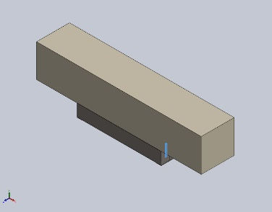 | Beam – Uniform C/S | Section Standard-weldment profiles/iso/square tube  Section Area: 0.000534796m^2  Length:350mm  Volume:0.000187182m^3  Mass Density:7,850kg/m^3  Mass:1.46938kg  Weight:14.3999N | E:\NIHVA AUTOMATION 2026\AUTOMATION\DOCK LEVELER\JLL\JLLSTRACTURE.SLDPRT  Oct 8 05:25:51 2025
SolidBody 2(Square tube 40 X 40 X 4(2)[2])  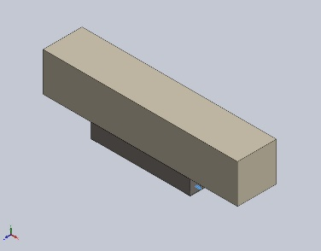 | Beam – Uniform C/S | Section Standard-weldment profiles/iso/square tube  Section Area: 0.000534796m^2  Length:100mm  Volume:5.34806e-05m^3  Mass Density:7,850kg/m^3  Mass:0.419823kg  Weight:4.11426N | E:\NIHVA AUTOMATION 2026\AUTOMATION\DOCK LEVELER\JLL\JLLSTRACTURE.SLDPRT  Oct 8 05:25:51 2025
SolidBody 3(Square tube 40 X 40 X 4(2)[1])  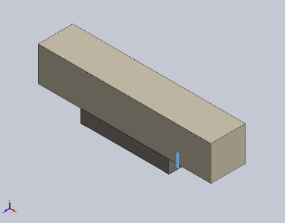 | Beam – Uniform C/S | Section Standard-weldment profiles/iso/square tube  Section Area: 0.000534796m^2  Length:350mm  Volume:0.000187179m^3  Mass Density:7,850kg/m^3  Mass:1.46936kg  Weight:14.3997N | E:\NIHVA AUTOMATION 2026\AUTOMATION\DOCK LEVELER\JLL\JLLSTRACTURE.SLDPRT  Oct 8 05:25:51 2025
SolidBody 1(Square tube 40 X 40 X 4(2)[3]) | Beam – Uniform C/S | Section Standard-weldment profiles/iso/square tube  Section Area: 0.000534796m^2  Length:350mm  Volume:0.000187182m^3  Mass Density:7,850kg/m^3  Mass:1.46938kg  Weight:14.3999N | E:\NIHVA AUTOMATION 2026\AUTOMATION\DOCK LEVELER\JLL\JLLSTRACTURE.SLDPRT  Oct 8 05:25:51 2025
SolidBody 2(Square tube 40 X 40 X 4(2)[2]) | Beam – Uniform C/S | Section Standard-weldment profiles/iso/square tube  Section Area: 0.000534796m^2  Length:100mm  Volume:5.34806e-05m^3  Mass Density:7,850kg/m^3  Mass:0.419823kg  Weight:4.11426N | E:\NIHVA AUTOMATION 2026\AUTOMATION\DOCK LEVELER\JLL\JLLSTRACTURE.SLDPRT  Oct 8 05:25:51 2025
SolidBody 3(Square tube 40 X 40 X 4(2)[1]) | Beam – Uniform C/S | Section Standard-weldment profiles/iso/square tube  Section Area: 0.000534796m^2  Length:350mm  Volume:0.000187179m^3  Mass Density:7,850kg/m^3  Mass:1.46936kg  Weight:14.3997N | E:\NIHVA AUTOMATION 2026\AUTOMATION\DOCK LEVELER\JLL\JLLSTRACTURE.SLDPRT  Oct 8 05:25:51 2025
SolidBody 1(Square tube 40 X 40 X 4(2)[3]) | Beam – Uniform C/S | Section Standard-weldment profiles/iso/square tube  Section Area: 0.000534796m^2  Length:350mm  Volume:0.000187182m^3  Mass Density:7,850kg/m^3  Mass:1.46938kg  Weight:14.3999N | E:\NIHVA AUTOMATION 2026\AUTOMATION\DOCK LEVELER\JLL\JLLSTRACTURE.SLDPRT  Oct 8 05:25:51 2025
SolidBody 2(Square tube 40 X 40 X 4(2)[2]) | Beam – Uniform C/S | Section Standard-weldment profiles/iso/square tube  Section Area: 0.000534796m^2  Length:100mm  Volume:5.34806e-05m^3  Mass Density:7,850kg/m^3  Mass:0.419823kg  Weight:4.11426N | E:\NIHVA AUTOMATION 2026\AUTOMATION\DOCK LEVELER\JLL\JLLSTRACTURE.SLDPRT  Oct 8 05:25:51 2025
SolidBody 3(Square tube 40 X 40 X 4(2)[1]) | Beam – Uniform C/S | Section Standard-weldment profiles/iso/square tube  Section Area: 0.000534796m^2  Length:350mm  Volume:0.000187179m^3  Mass Density:7,850kg/m^3  Mass:1.46936kg  Weight:14.3997N | E:\NIHVA AUTOMATION 2026\AUTOMATION\DOCK LEVELER\JLL\JLLSTRACTURE.SLDPRT  Oct 8 05:25:51 2025
SolidBody 1(Square tube 40 X 40 X 4(2)[3]) | Beam – Uniform C/S | Section Standard-weldment profiles/iso/square tube  Section Area: 0.000534796m^2  Length:350mm  Volume:0.000187182m^3  Mass Density:7,850kg/m^3  Mass:1.46938kg  Weight:14.3999N | E:\NIHVA AUTOMATION 2026\AUTOMATION\DOCK LEVELER\JLL\JLLSTRACTURE.SLDPRT  Oct 8 05:25:51 2025
SolidBody 2(Square tube 40 X 40 X 4(2)[2]) | Beam – Uniform C/S | Section Standard-weldment profiles/iso/square tube  Section Area: 0.000534796m^2  Length:100mm  Volume:5.34806e-05m^3  Mass Density:7,850kg/m^3  Mass:0.419823kg  Weight:4.11426N | E:\NIHVA AUTOMATION 2026\AUTOMATION\DOCK LEVELER\JLL\JLLSTRACTURE.SLDPRT  Oct 8 05:25:51 2025
SolidBody 3(Square tube 40 X 40 X 4(2)[1]) | Beam – Uniform C/S | Section Standard-weldment profiles/iso/square tube  Section Area: 0.000534796m^2  Length:350mm  Volume:0.000187179m^3  Mass Density:7,850kg/m^3  Mass:1.46936kg  Weight:14.3997N | E:\NIHVA AUTOMATION 2026\AUTOMATION\DOCK LEVELER\JLL\JLLSTRACTURE.SLDPRT  Oct 8 05:25:51 2025

Study Properties
Study name | Static 2
Analysis type | Static
Mesh type | Mixed Mesh
Thermal Effect: | On
Thermal option | Include temperature loads
Zero strain temperature | 298 Kelvin
Include fluid pressure effects from SOLIDWORKS Flow Simulation | Off
Solver type | Automatic
Inplane Effect: | Off
Soft Spring: | Off
Inertial Relief: | Off
Incompatible bonding options | Automatic
Large displacement | Off
Compute free body forces | On
Friction | Off
Use Adaptive Method: | Off
Result folder | SOLIDWORKS document (E:\NIHVA AUTOMATION 2026\AUTOMATION\DOCK LEVELER\JLL)

Units
Unit system: | SI (MKS)
Length/Displacement | mm
Temperature | Kelvin
Angular velocity | Rad/sec
Pressure/Stress | N/m^2

Material Properties
Model Reference | Properties | Components
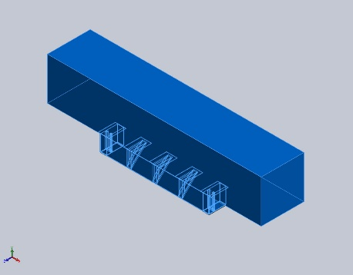 |  | SolidBody 1(C channel 100 X 10(1)[1])(C CHANEL-1),  SolidBody 2(C channel 100 X 10(1)[2])(C CHANEL-1),  SolidBody 3(C channel 100 X 10(1)[3])(C CHANEL-1),  SolidBody 1(C channel 100 X 10(1)[1])(C CHANEL-2),  SolidBody 2(C channel 100 X 10(1)[2])(C CHANEL-2),  SolidBody 3(C channel 100 X 10(1)[3])(C CHANEL-2),  SolidBody 1(C channel 100 X 10(1)[1])(C CHANEL-3),  SolidBody 2(C channel 100 X 10(1)[2])(C CHANEL-3),  SolidBody 3(C channel 100 X 10(1)[3])(C CHANEL-3),  SolidBody 1(Base-Flange1)(JLL CHEQURED PLATE - 8 MM-1),  SolidBody 1(Convert-Solid1)(JLLAssem1-1/JLLDOCK BUMPER BOX-1),  SolidBody 1(Boss-Extrude1)(JLLAssem1-1/JLLPLATE BOTTOM-1),  SolidBody 1(Square tube 40 X 40 X 4(2)[3])(JLLAssem1-1/JLLSTRACTURE-2),  SolidBody 2(Square tube 40 X 40 X 4(2)[2])(JLLAssem1-1/JLLSTRACTURE-2),  SolidBody 3(Square tube 40 X 40 X 4(2)[1])(JLLAssem1-1/JLLSTRACTURE-2),  SolidBody 1(Convert-Solid1)(JLLAssem1-2/JLLDOCK BUMPER BOX-1),  SolidBody 1(Boss-Extrude1)(JLLAssem1-2/JLLPLATE BOTTOM-1),  SolidBody 1(Square tube 40 X 40 X 4(2)[3])(JLLAssem1-2/JLLSTRACTURE-2),  SolidBody 2(Square tube 40 X 40 X 4(2)[2])(JLLAssem1-2/JLLSTRACTURE-2),  SolidBody 3(Square tube 40 X 40 X 4(2)[1])(JLLAssem1-2/JLLSTRACTURE-2),  SolidBody 1(Boss-Extrude1)(JLLBS-1),  SolidBody 1(Boss-Extrude1)(JLLPLATE BOTTOM-1),  SolidBody 1(Boss-Extrude1)(JLLPLATE BOTTOM-2),  SolidBody 1(Boss-Extrude1)(JLLPLATE BOTTOM-3)
  Name: | AISI 4340 Steel, normalized
  Model type: | Linear Elastic Isotropic
  Default failure criterion: | Max von Mises Stress
  Yield strength: | 7.1e+08 N/m^2
  Tensile strength: | 1.11e+09 N/m^2
  Elastic modulus: | 2.05e+11 N/m^2
  Poisson's ratio: | 0.32
  Mass density: | 7,850 kg/m^3
  Shear modulus: | 8e+10 N/m^2
  Thermal expansion coefficient: | 1.23e-05 /Kelvin
Curve Data:N/A
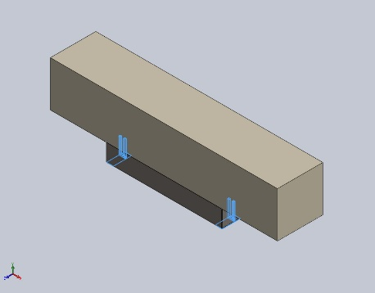 |  | SolidBody 1(Boss-Extrude1)(JLLAssem1-1/JLLPLATE-1),  SolidBody 1(Square tube 40 X 40 X 4(2)[3])(JLLAssem1-1/JLLSTRACTURE-1),  SolidBody 2(Square tube 40 X 40 X 4(2)[2])(JLLAssem1-1/JLLSTRACTURE-1),  SolidBody 3(Square tube 40 X 40 X 4(2)[1])(JLLAssem1-1/JLLSTRACTURE-1),  SolidBody 1(Boss-Extrude1)(JLLAssem1-2/JLLPLATE-1),  SolidBody 1(Square tube 40 X 40 X 4(2)[3])(JLLAssem1-2/JLLSTRACTURE-1),  SolidBody 2(Square tube 40 X 40 X 4(2)[2])(JLLAssem1-2/JLLSTRACTURE-1),  SolidBody 3(Square tube 40 X 40 X 4(2)[1])(JLLAssem1-2/JLLSTRACTURE-1)
  Name: | AISI 4340 Steel, annealed
  Model type: | Linear Elastic Isotropic
  Default failure criterion: | Unknown
  Yield strength: | 4.7e+08 N/m^2
  Tensile strength: | 7.45e+08 N/m^2
  Elastic modulus: | 2.05e+11 N/m^2
  Poisson's ratio: | 0.285
  Mass density: | 7,850 kg/m^3
  Shear modulus: | 8e+10 N/m^2
  Thermal expansion coefficient: | 1.23e-05 /Kelvin
Curve Data:N/A

Loads and Fixtures
Fixture name | Fixture Image | Fixture Details
Reference Geometry-1 | 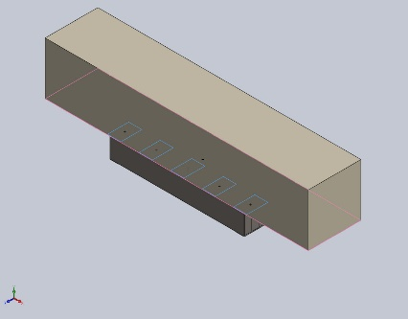
  Entities: | 5 face(s)
  Reference: | Face< 1 >
  Type: | Use reference geometry
  Translation: | ---, -0, ---
  Rotation: | ---, ---, ---
  Units: | mm, rad
Resultant Forces
Components | X | Y | Z | Resultant
Reaction force(N) | 0 | 0 | -143.9 | 143.9
Reaction Moment(N.m) | 0 | 0 | 0 | 1e-33

Load name | Load Image | Load Details
Force-1 | 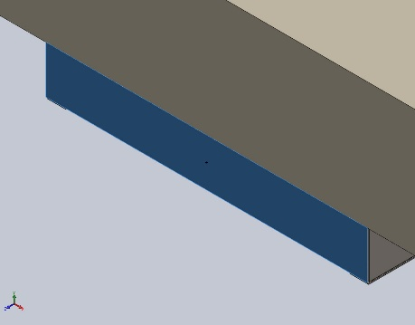
  Entities: | 1 face(s)
  Type: | Apply normal force
  Value: | 1,000 N

Connector Definitions
No Data

Interaction Information

Interaction | Interaction Image | Interaction Properties
Global Interaction | 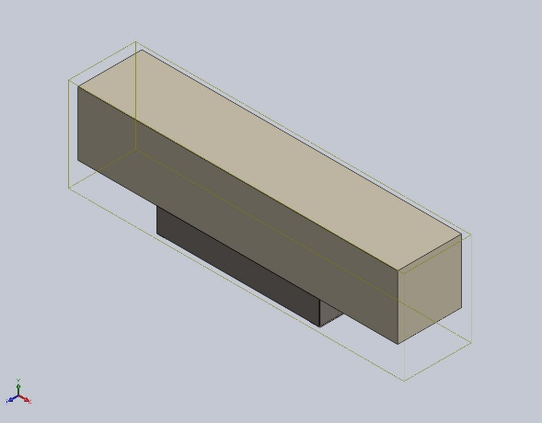
  Type: | Bonded
  Components: | 1 component(s)
  Options: | Independent mesh

Mesh information
Mesh type | Mixed Mesh
Mesher Used: | Blended curvature-based mesh
Jacobian points for High quality mesh | 16 Points
Jacobian check for shell | On
Maximum element size | 342.595 mm
Minimum element size | 17.1297 mm
Mesh Quality | High
Remesh failed parts independently | Off

Mesh information - Details
Total Nodes | 19984
Total Elements | 9756
Time to complete mesh(hh;mm;ss): | 00:00:11
Computer name:

Mesh Control Information:
Mesh Control Name | Mesh Control Image | Mesh Control Details
Control-1 | 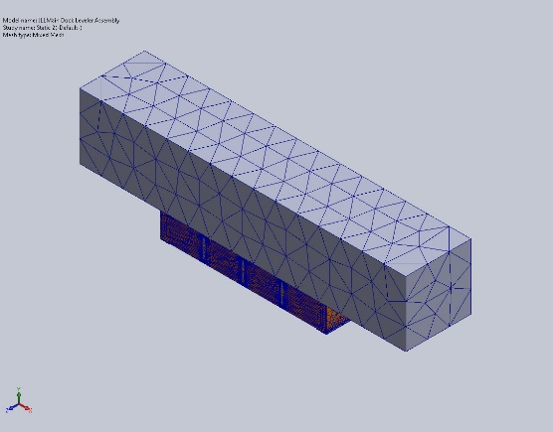
  Entities: | 1 component(s)
  Units: | mm
  Size: | 171.297
  Ratio: | 171.297

Sensor Details
No Data

Resultant Forces

Reaction forces
Selection set | Units | Sum X | Sum Y | Sum Z | Resultant
Entire Model | N | 1.07041e-12 | -1.59761e-14 | -143.9 | 143.9

Reaction Moments
Selection set | Units | Sum X | Sum Y | Sum Z | Resultant
Entire Model | N.m | 0 | 0 | 0 | 1e-33

Free body forces
Selection set | Units | Sum X | Sum Y | Sum Z | Resultant
Entire Model | N | -0.0825228 | 17.4481 | 36.4518 | 40.4126

Free body moments
Selection set | Units | Sum X | Sum Y | Sum Z | Resultant
Entire Model | N.m | -155.797 | 34.3714 | 25.7823 | 161.613

Beams

Beam Forces
Beam Name | Joints | Axial(N) | Shear1(N) | Shear2(N) | Moment1(N.m) | Moment2(N.m) | Torque(N.m)
Beam-1(C channel 100 X 10(1)[1]) | 1 | -18.8232 | 0.294577 | -6.35062 | 0.828494 | 0.0701175 | 0.000373367
Beam-1(C channel 100 X 10(1)[1]) | 2 | 18.8233 | -0.294598 | 6.35043 | 1.27084 | 0.0271816 | -0.000761709
Beam-2(C channel 100 X 10(1)[2]) | 1 | -454.596 | -1.89763 | 0.320767 | 0.509829 | 0.298231 | -0.000684958
Beam-2(C channel 100 X 10(1)[2]) | 2 | 454.596 | 1.8977 | -0.319943 | -0.37097 | 0.501948 | 0.00123223
Beam-3(C channel 100 X 10(1)[3]) | 1 | -21,901 | -280.854 | 349.637 | 22.0009 | 24.6834 | -0.057817
Beam-3(C channel 100 X 10(1)[3]) | 2 | -22,086.9 | 294.082 | -1,764.24 | -82.7749 | 23.6404 | -0.0606221
Beam-4(C channel 100 X 10(1)[1]) | 1 | 72.9786 | -1.94262 | 9.67898 | -0.980259 | 0.00143566 | 0.000354465
Beam-4(C channel 100 X 10(1)[1]) | 2 | -72.9786 | 1.9426 | -9.67895 | -2.07245 | -0.614494 | -0.000742827
Beam-5(C channel 100 X 10(1)[2]) | 1 | -274.898 | -6.73374 | -2.90398 | -0.130416 | 0.751956 | -0.002677
Beam-5(C channel 100 X 10(1)[2]) | 2 | 274.897 | 6.73381 | 2.90442 | -1.13256 | 2.18439 | 0.00322482
Beam-6(C channel 100 X 10(1)[3]) | 1 | -65.5386 | -184.259 | 527.063 | -41.1224 | -15.9915 | 0.0182037
Beam-6(C channel 100 X 10(1)[3]) | 2 | 69.4962 | -216.117 | 516.908 | 38.2903 | 14.0522 | 0.00798751
Beam-7(C channel 100 X 10(1)[1]) | 1 | 30.8701 | -8.96972 | 9.01083 | -0.91147 | -0.659312 | -0.00106178
Beam-7(C channel 100 X 10(1)[1]) | 2 | -30.8701 | 8.9697 | -9.01059 | -1.93035 | -2.1714 | 0.000673417
Beam-8(C channel 100 X 10(1)[2]) | 1 | -140.686 | -9.49412 | 4.06966 | 0.65936 | 1.8122 | -0.00818983
Beam-8(C channel 100 X 10(1)[2]) | 2 | 140.686 | 9.4942 | -4.06949 | 1.11925 | 2.32808 | 0.00873761
Beam-9(C channel 100 X 10(1)[3]) | 1 | 407.61 | 117.541 | -199.811 | 10.1895 | 4.97419 | -0.00782765
Beam-9(C channel 100 X 10(1)[3]) | 2 | 352.628 | 73.3301 | 6.64312 | -2.85084 | -6.5276 | -0.0194468
Beam-13(Square tube 40 X 40 X 4(2)[3]) | 1 | 5,097 | 487.868 | 1,455.29 | -47.8752 | 201.128 | -29.6337
Beam-13(Square tube 40 X 40 X 4(2)[3]) | 2 | -7,089.11 | -651.67 | 848.734 | 118.149 | -45.4775 | -19.7805
Beam-14(Square tube 40 X 40 X 4(2)[2]) | 1 | 822.686 | 2,009.81 | -3,457.63 | 148.172 | 155.195 | 100.348
Beam-14(Square tube 40 X 40 X 4(2)[2]) | 2 | -708.849 | -1,471.91 | 353.804 | 41.2897 | 19.009 | -31.638
Beam-15(Square tube 40 X 40 X 4(2)[1]) | 1 | -12,061.7 | -718.165 | -111.321 | -1.90159 | 79.7117 | -0.660332
Beam-15(Square tube 40 X 40 X 4(2)[1]) | 2 | -879.047 | 704.039 | 191.659 | -17.2247 | -45.2071 | -0.968881
Beam-19(Square tube 40 X 40 X 4(2)[3]) | 1 | 3,066.88 | -276.776 | -202.537 | -10.7832 | -44.4404 | 3.08412
Beam-19(Square tube 40 X 40 X 4(2)[3]) | 2 | 1,826.16 | 72.0364 | 1,371.05 | 53.1971 | 75.7959 | -36.2978
Beam-20(Square tube 40 X 40 X 4(2)[2]) | 1 | -1,720.05 | 11,070.6 | 458.405 | 28.5409 | 360.946 | -19.2377
Beam-20(Square tube 40 X 40 X 4(2)[2]) | 2 | -621.224 | 4,369.97 | 1,056.48 | 1.9325 | -81.6943 | -13.7223
Beam-21(Square tube 40 X 40 X 4(2)[1]) | 1 | -7,066.44 | 27.7863 | -45.1422 | -7.43294 | 85.7152 | -2.15652
Beam-21(Square tube 40 X 40 X 4(2)[1]) | 2 | 3,267.53 | -0.523532 | 220.111 | -6.22137 | -1.5015 | 6.31775
Beam-22(Square tube 40 X 40 X 4(2)[3]) | 1 | 12,724.6 | -1,345.04 | 1,206.57 | -40.0287 | 54.3562 | -25.4749
Beam-22(Square tube 40 X 40 X 4(2)[3]) | 2 | 8,921.66 | 1,352.65 | 190.172 | 30.3686 | -55.5925 | -5.08727
Beam-23(Square tube 40 X 40 X 4(2)[2]) | 1 | -5,705.33 | -8,844.3 | 2,158.03 | -46.5983 | -156.719 | -31.1732
Beam-23(Square tube 40 X 40 X 4(2)[2]) | 2 | 3,394.45 | -10,548.9 | 876.782 | -17.6926 | 185.978 | -35.0285
Beam-24(Square tube 40 X 40 X 4(2)[1]) | 1 | 416.577 | 497.874 | 839.735 | -28.9596 | 12.2929 | 13.0048
Beam-24(Square tube 40 X 40 X 4(2)[1]) | 2 | 9,665.64 | -583.486 | 1,038.36 | 40.2912 | -39.3591 | 26.6245
Beam-25(Square tube 40 X 40 X 4(2)[3]) | 1 | -12,366.1 | 432.309 | -1,005.66 | 44.6982 | -139.354 | 16.4757
Beam-25(Square tube 40 X 40 X 4(2)[3]) | 2 | 3,568.27 | -315.838 | -418.559 | -7.74066 | 70.6393 | 8.99843
Beam-26(Square tube 40 X 40 X 4(2)[2]) | 1 | 1,267.86 | -12,650.1 | -2,562.22 | 54.2218 | -318.857 | 46.8116
Beam-26(Square tube 40 X 40 X 4(2)[2]) | 2 | 3,092.3 | -5,595.66 | -3,848.77 | -118.129 | 58.6252 | 95.0741
Beam-27(Square tube 40 X 40 X 4(2)[1]) | 1 | -4,470.13 | -180.458 | 755.857 | -26.2753 | 64.33 | 17.1391
Beam-27(Square tube 40 X 40 X 4(2)[1]) | 2 | 7,008.06 | 158.565 | 1,556.1 | 102.901 | -175.218 | 32.5784

Beam Stresses
Beam Name | Joints | Axial(N/m^2) | Bending Dir1(N/m^2) | Bending Dir2(N/m^2) | Torsional (N/m^2) | Upper bound axial and bending(N/m^2)
Beam-1(C channel 100 X 10(1)[1]) | 1 | 14,366.9 | -105,341 | 1,753.52 | -1,111.31 | 121,461
Beam-1(C channel 100 X 10(1)[1]) | 2 | 14,367 | 161,584 | -679.766 | -2,267.2 | 176,631
Beam-2(C channel 100 X 10(1)[2]) | 1 | -346,973 | 64,823.3 | -7,458.26 | -2,038.75 | 419,255
Beam-2(C channel 100 X 10(1)[2]) | 2 | -346,973 | 47,167.8 | 12,552.9 | -3,667.68 | 406,694
Beam-3(C channel 100 X 10(1)[3]) | 1 | 1.67161e+07 | -2.79735e+06 | 617,290 | 172,090 | 2.01307e+07
Beam-3(C channel 100 X 10(1)[3]) | 2 | -1.6858e+07 | -1.05246e+07 | -591,208 | -180,439 | 2.79738e+07
Beam-4(C channel 100 X 10(1)[1]) | 1 | -55,701.4 | 124,637 | 35.9034 | -1,055.05 | 180,374
Beam-4(C channel 100 X 10(1)[1]) | 2 | -55,701.4 | -263,507 | 15,367.5 | -2,210.99 | 334,575
Beam-5(C channel 100 X 10(1)[2]) | 1 | -209,818 | -16,582 | -18,805.2 | -7,967.98 | 245,205
Beam-5(C channel 100 X 10(1)[2]) | 2 | -209,817 | 144,001 | 54,628 | -9,598.54 | 408,447
Beam-6(C channel 100 X 10(1)[3]) | 1 | 50,022.7 | 5.22859e+06 | -399,921 | -54,182.6 | 5.67853e+06
Beam-6(C channel 100 X 10(1)[3]) | 2 | 53,043.4 | 4.8685e+06 | -351,421 | 23,774.5 | 5.27297e+06
Beam-7(C channel 100 X 10(1)[1]) | 1 | -23,561.8 | 115,891 | -16,488.3 | 3,160.34 | 155,941
Beam-7(C channel 100 X 10(1)[1]) | 2 | -23,561.8 | -245,438 | 54,303.1 | 2,004.4 | 323,303
Beam-8(C channel 100 X 10(1)[2]) | 1 | -107,380 | 83,835.7 | -45,320.1 | -24,376.7 | 236,536
Beam-8(C channel 100 X 10(1)[2]) | 2 | -107,379 | -142,309 | 58,221.3 | -26,007.1 | 307,910
Beam-9(C channel 100 X 10(1)[3]) | 1 | -311,111 | -1.29556e+06 | 124,396 | 23,298.7 | 1.73107e+06
Beam-9(C channel 100 X 10(1)[3]) | 2 | 269,145 | -362,476 | 163,244 | -57,882.7 | 794,866
Beam-13(Square tube 40 X 40 X 4(2)[3]) | 1 | -9.53073e+06 | 8.6459e+06 | 3.63221e+07 | 3.81761e+06 | 5.44988e+07
Beam-13(Square tube 40 X 40 X 4(2)[3]) | 2 | -1.32557e+07 | 2.13369e+07 | 8.21289e+06 | -2.54826e+06 | 4.28055e+07
Beam-14(Square tube 40 X 40 X 4(2)[2]) | 1 | -1.53832e+06 | -2.67587e+07 | 2.80271e+07 | -1.29275e+07 | 5.63242e+07
Beam-14(Square tube 40 X 40 X 4(2)[2]) | 2 | -1.32546e+06 | 7.4566e+06 | -3.43289e+06 | -4.07581e+06 | 1.22149e+07
Beam-15(Square tube 40 X 40 X 4(2)[1]) | 1 | 2.25538e+07 | 343,412 | 1.43953e+07 | 85,066.3 | 3.72925e+07
Beam-15(Square tube 40 X 40 X 4(2)[1]) | 2 | -1.6437e+06 | -3.11065e+06 | 8.16406e+06 | -124,815 | 1.29184e+07
Beam-19(Square tube 40 X 40 X 4(2)[3]) | 1 | -5.73467e+06 | 1.94736e+06 | -8.02561e+06 | -397,316 | 1.57076e+07
Beam-19(Square tube 40 X 40 X 4(2)[3]) | 2 | 3.41468e+06 | 9.607e+06 | -1.36882e+07 | -4.67612e+06 | 2.67098e+07
Beam-20(Square tube 40 X 40 X 4(2)[2]) | 1 | 3.21628e+06 | -5.15427e+06 | 6.51841e+07 | 2.47833e+06 | 7.35546e+07
Beam-20(Square tube 40 X 40 X 4(2)[2]) | 2 | -1.16161e+06 | 348,995 | 1.47534e+07 | -1.7678e+06 | 1.6264e+07
Beam-21(Square tube 40 X 40 X 4(2)[1]) | 1 | 1.32133e+07 | 1.34233e+06 | 1.54795e+07 | 277,811 | 3.00352e+07
Beam-21(Square tube 40 X 40 X 4(2)[1]) | 2 | 6.10987e+06 | -1.12353e+06 | 271,160 | 813,876 | 7.50456e+06
Beam-22(Square tube 40 X 40 X 4(2)[3]) | 1 | -2.37934e+07 | 7.22889e+06 | 9.81631e+06 | 3.28184e+06 | 4.08386e+07
Beam-22(Square tube 40 X 40 X 4(2)[3]) | 2 | 1.66824e+07 | 5.48434e+06 | 1.00396e+07 | -655,375 | 3.22063e+07
Beam-23(Square tube 40 X 40 X 4(2)[2]) | 1 | 1.06682e+07 | 8.41531e+06 | -2.83023e+07 | 4.01594e+06 | 4.73859e+07
Beam-23(Square tube 40 X 40 X 4(2)[2]) | 2 | 6.34718e+06 | -3.19514e+06 | -3.35863e+07 | -4.5126e+06 | 4.31286e+07
Beam-24(Square tube 40 X 40 X 4(2)[1]) | 1 | -778,945 | 5.22988e+06 | 2.22001e+06 | -1.67532e+06 | 8.22884e+06
Beam-24(Square tube 40 X 40 X 4(2)[1]) | 2 | 1.80735e+07 | 7.27628e+06 | 7.10796e+06 | 3.42986e+06 | 3.24577e+07
Beam-25(Square tube 40 X 40 X 4(2)[3]) | 1 | 2.31229e+07 | -8.07215e+06 | -2.51662e+07 | -2.1225e+06 | 5.63613e+07
Beam-25(Square tube 40 X 40 X 4(2)[3]) | 2 | 6.67221e+06 | -1.39791e+06 | -1.27569e+07 | 1.15924e+06 | 2.0827e+07
Beam-26(Square tube 40 X 40 X 4(2)[2]) | 1 | -2.37073e+06 | -9.79205e+06 | -5.75832e+07 | -6.03057e+06 | 6.9746e+07
Beam-26(Square tube 40 X 40 X 4(2)[2]) | 2 | 5.7822e+06 | -2.13331e+07 | -1.05873e+07 | 1.22481e+07 | 3.77026e+07
Beam-27(Square tube 40 X 40 X 4(2)[1]) | 1 | 8.35857e+06 | 4.74512e+06 | 1.16175e+07 | -2.20792e+06 | 2.47212e+07
Beam-27(Square tube 40 X 40 X 4(2)[1]) | 2 | 1.31042e+07 | 1.85831e+07 | 3.16431e+07 | 4.19686e+06 | 6.33304e+07

Study Results

Name | Type | Min | Max
Stress1 | VON: von Mises Stress | 0.000e+00N/m^2  Node: 19884 | 2.214e+08N/m^2  Node: 11150
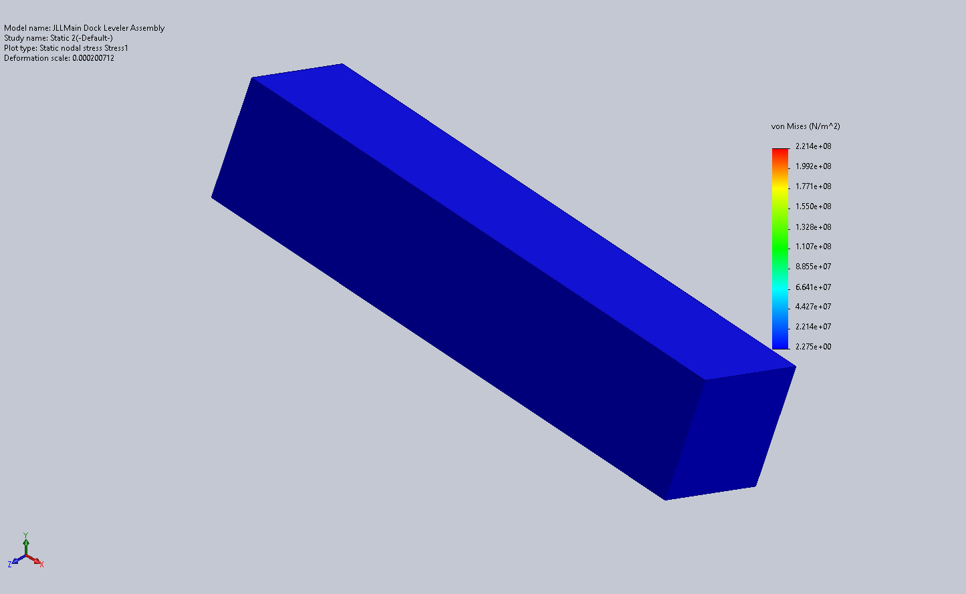
JLLMain Dock Leveler Assembly-Static 2-Stress-Stress1

Name | Type | Min | Max
Displacement1 | URES: Resultant Displacement | 0.000e+00mm  Node: 19964 | 3.119e+06mm  Node: 16865
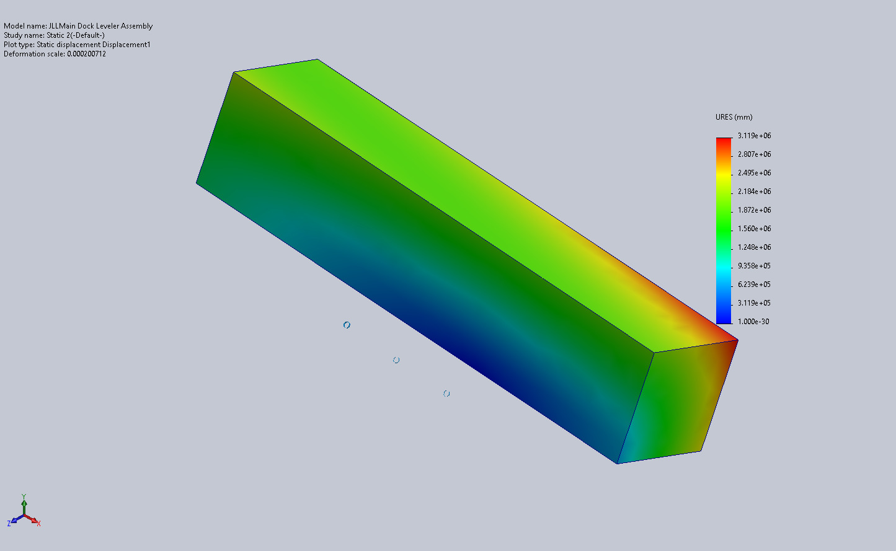
JLLMain Dock Leveler Assembly-Static 2-Displacement-Displacement1

Name | Type | Min | Max
Strain1 | ESTRN: Equivalent Strain | 0.000e+00  Element: 9681 | 5.869e-04  Element: 6221
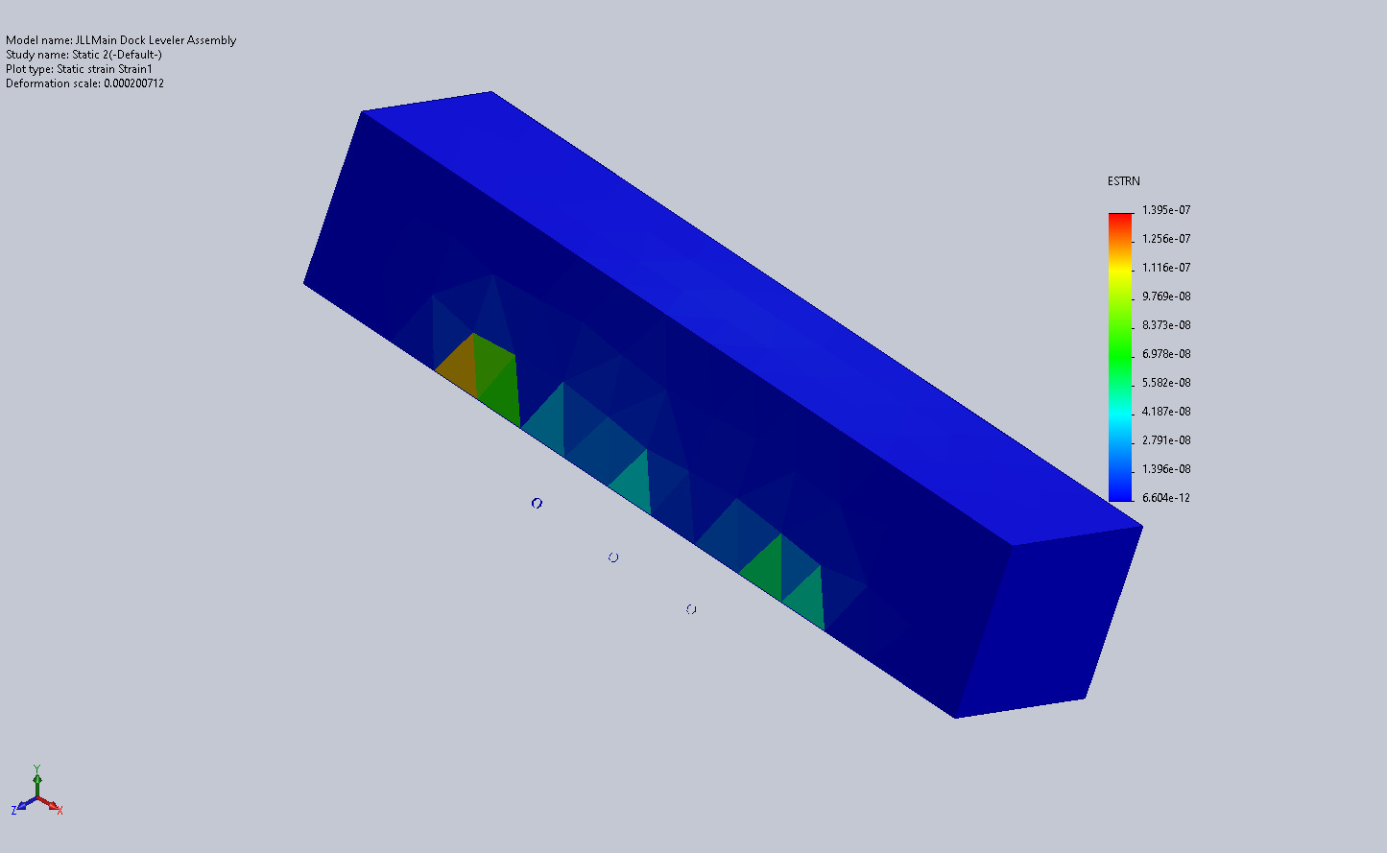
JLLMain Dock Leveler Assembly-Static 2-Strain-Strain1

Conclusion

